PYNQ-Z2 Current Folders
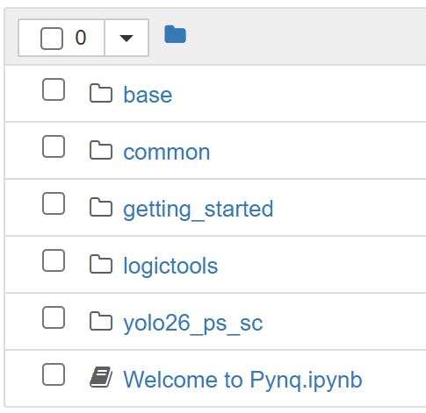 | I put all the files in yolo26n_ps, _sc means shortcut.
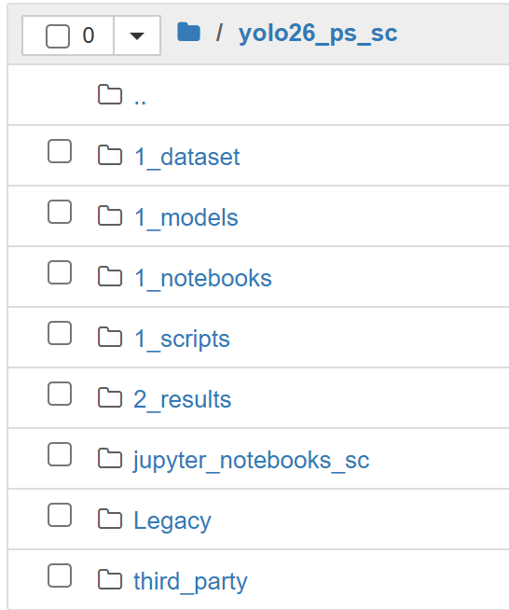 | This is the current folder structure:  - dataset, models, scripts, results folders are as you thought.  - jupter_notebook_sc is a shortcut to home; 1_notebooks is the one that contains ipynb.  - Legacy is archived files; they are not used, but I keep them just in case. All the Legacy folders can be deleted once the project is done.
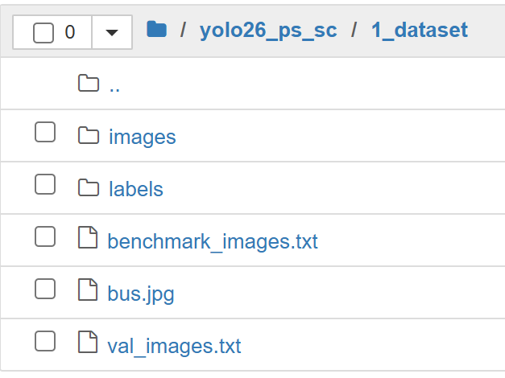 | The dataset folder contains images for testing / measuring.
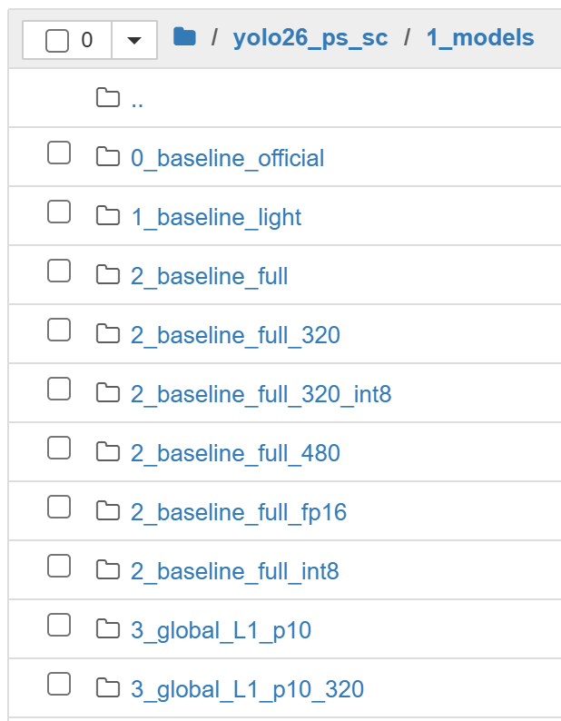 | The model folder contains NCNN models for PYNQ to run.  Default:  - prune 0%  - 640 x 640  - FP32  To identify the models, their folders are named as: index_model_p0_640_fp32
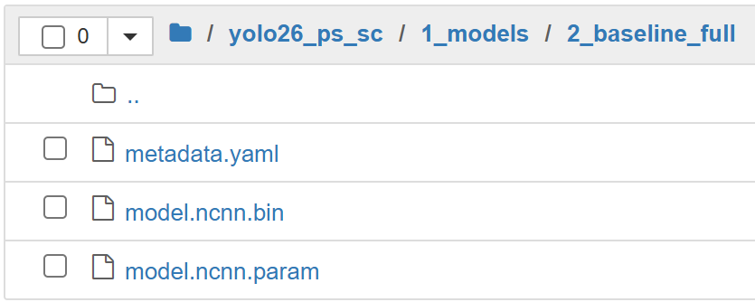 | Each model in the model folder needs yaml, bin, and param files.  The .pt file is not needed.
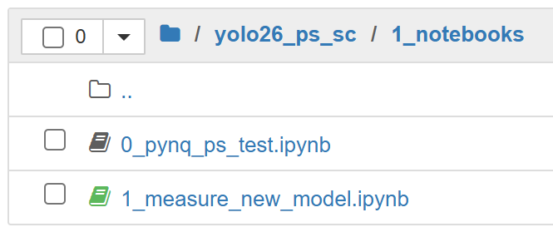 | The notebooks folder contains ipynbs for Jupyter notebooks.
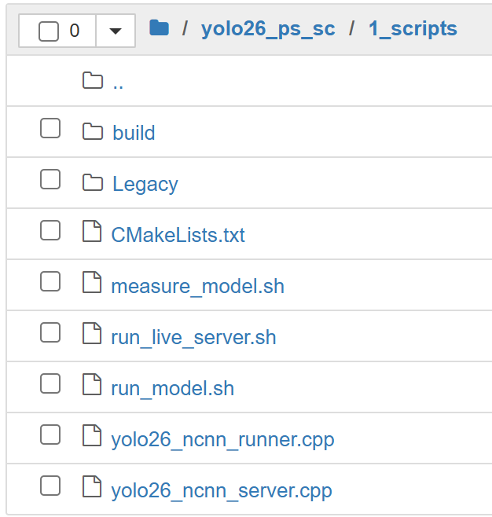 | run_model and measure_model are the main scripts used to measure each model's performance on the PYNQ PS side.  yolo26_ncnnrunner.cpp will be used to run the ncnn model.
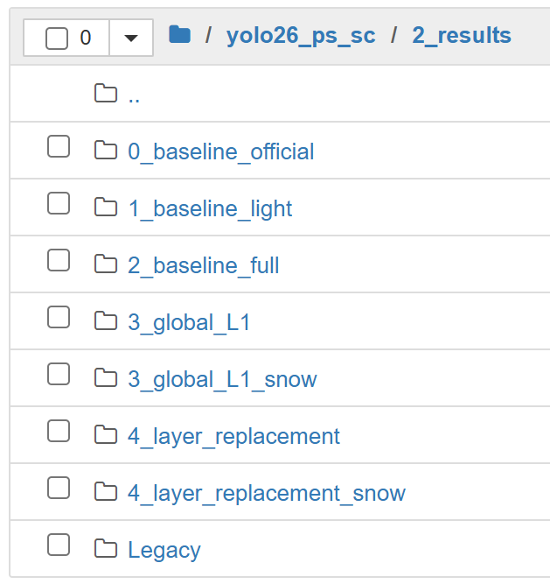 | Results folder.  For each model, same folder name as the model folder.
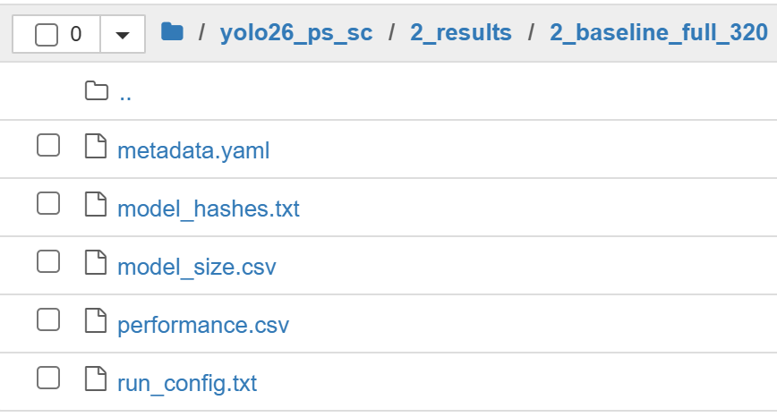 | Results, the main one for latency / FPS will be performance.csv

Model Measuring in PYNQ
Step 1: From (.pt) to (.ncnn)
1.1 pt -> non-int8 ncnn
export_baseline_ncnn.py  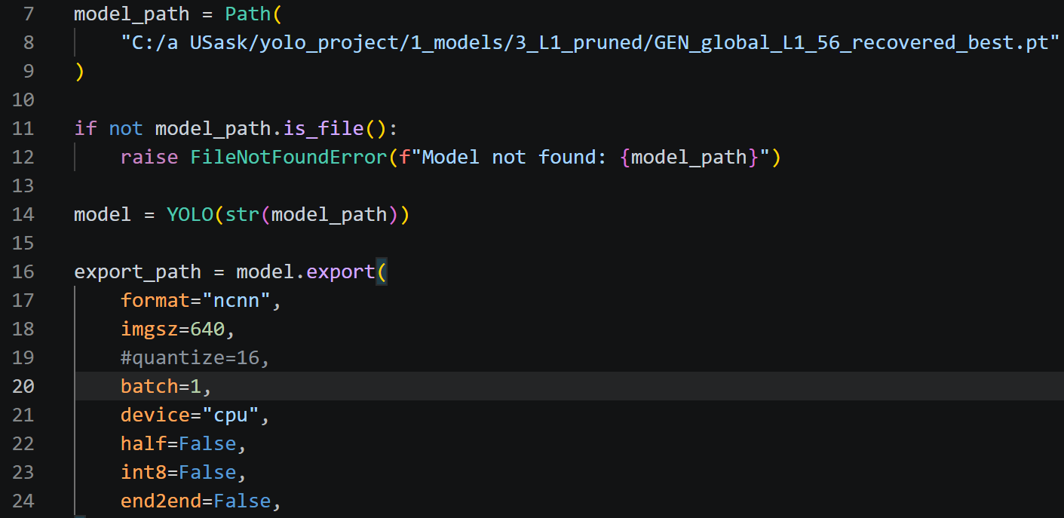  For each pt model, edit:  - [model_path] pt model path  - [imgsz] Image resolution  - [quantize] default 32, can be 16 | Outputs:  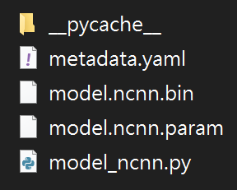  Needed for PYNQ:  - metadata.yaml  - model.ncnn.bin  - model.ncnn.param  Put them in:  - /yolo26_ps/1_model/  [model_name]/

1.2 pt -> int8 ncnn
export_pt_to_int8_ncnn.py  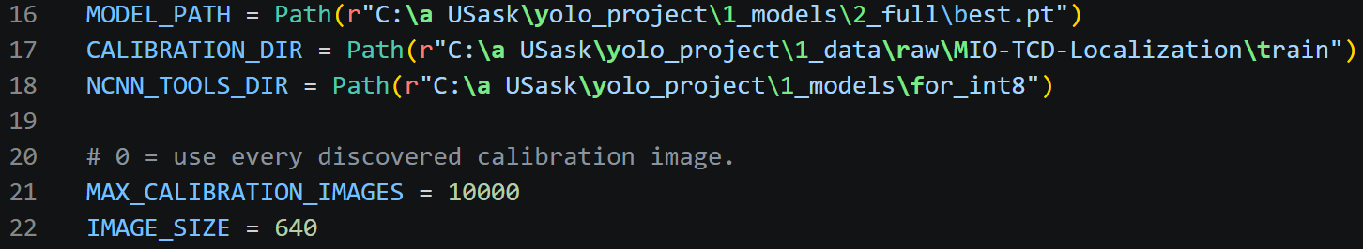  For each pt model, edit:  - [model_path] pt model path  - [calibration_dir] images for calibration (I used MIO-TCD training images)  - [ncnn_tools_dir] downloaded online  - [max_calibration_images] recommend 5000+, I used 10000  - [image_size] Image resolution | Outputs:  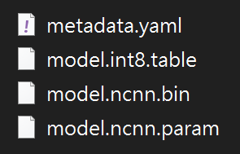

Step 2: Model measurements
2.1 measuring
The main ipynb for measurements. | yolo26_ps/1_notebooks/  1_measure_new_model.ipynb  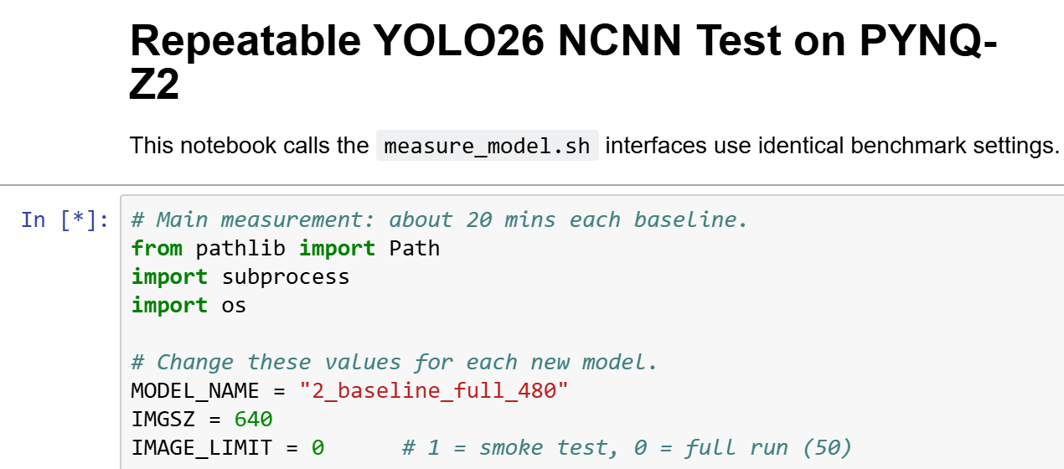  This runs the model and generates the result files. For the current FPS, it is around 20 mins per baseline.  For each ncnn model, edit:  - [model_name] matches the model folder in /yolo26_ps/1_models/  - [imgsz] Image resolution  - [image_limit] amount or 0 for full 50 test

2.2 edit measurement settings
For general settings, you can edit run_model.sh.  For the advanced ncnn runner, you can edit yolo26_ncnn_runner.cpp. | yolo26_ps/1_scripts/  run_model.sh  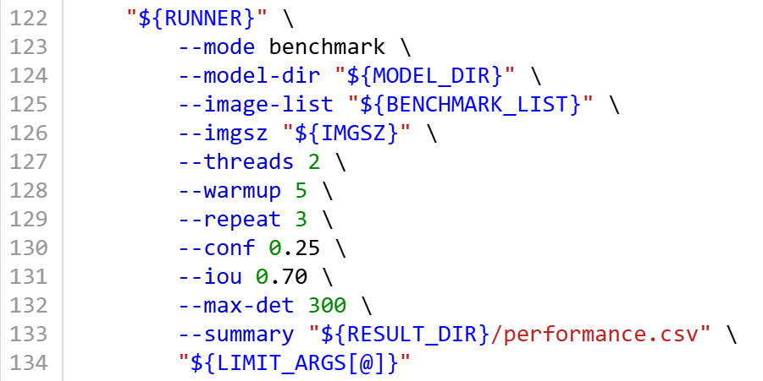  Hardcoded numbers here are all editable; they exist in both benchmark and validation functions.  However, I think it is fine to keep this for every model.

Step 3: Measurement results
3.1 result files
Results are in /yolo26_ps/2_results. | 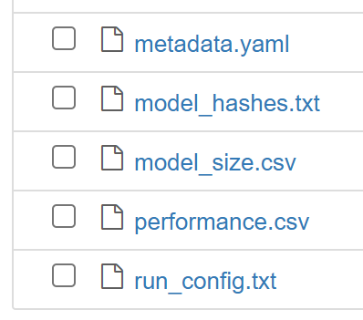  For each model, they will have the files listed above.  For latency, the most important one is performance.csv.

3.2 zip
yolo26_ps/1_notebooks/  1_measure_new_model.ipynb  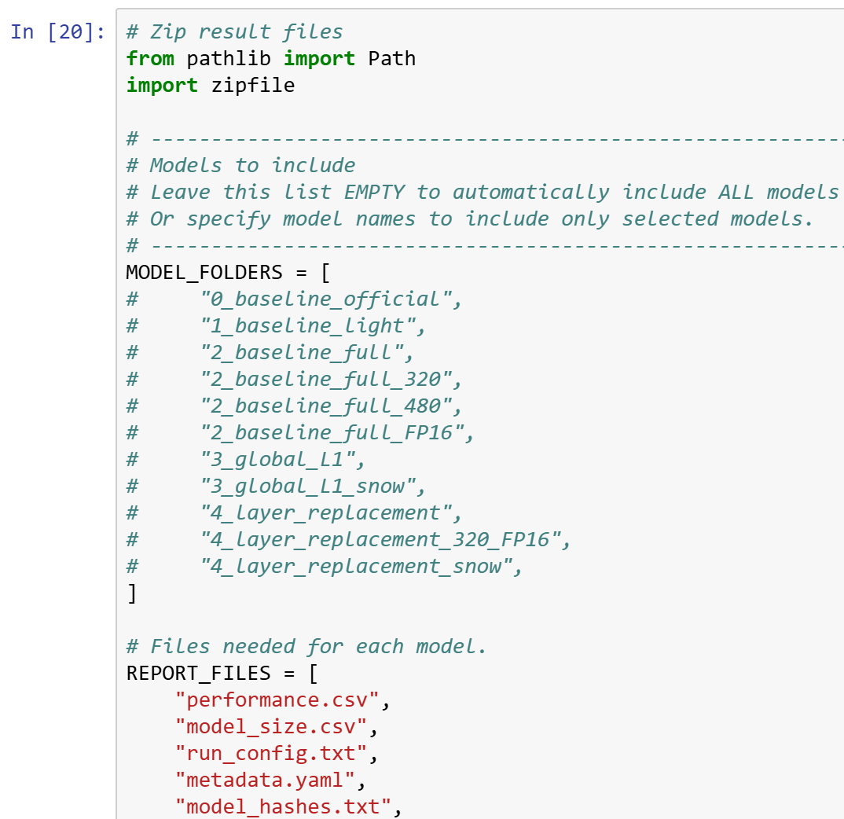  This makes the result folder a zip file for download; the required files can be edited. | yolo26_ps/  zip_all.ipynb  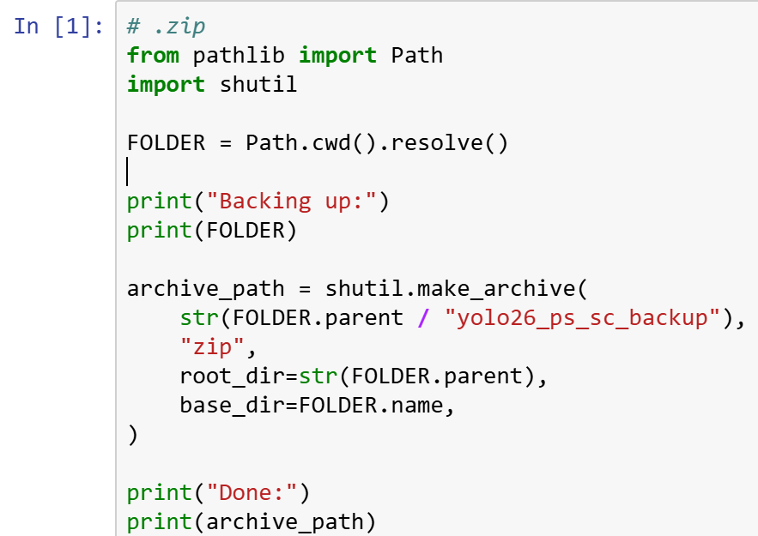  This zips the whole yolo26_ps folder for backup.

PC-PYNQ Video Real-Time Running
Step 1: Select model on PYNQ
In PYNQ terminal:
cd yolo26_ps
bash 1_scripts/run_live_server.sh [model_folder_name]

Step 2: Select Video, resolution on PC
Stream_video.py
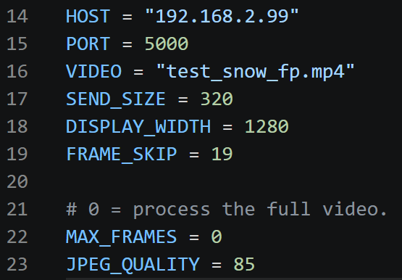  Before running, edit:  - [video] the video name  - [send_size] change according to the current model  - [frame_skip] can change according to the FPS | 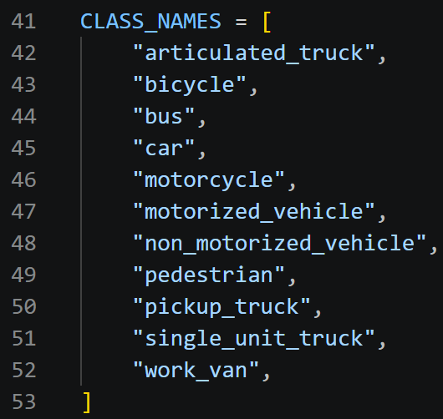  Classes are hardcoded; this may need to change if the model has a different YAML format.

Step 3: Results
A window will appear on the PC with the selected video and result boxes.
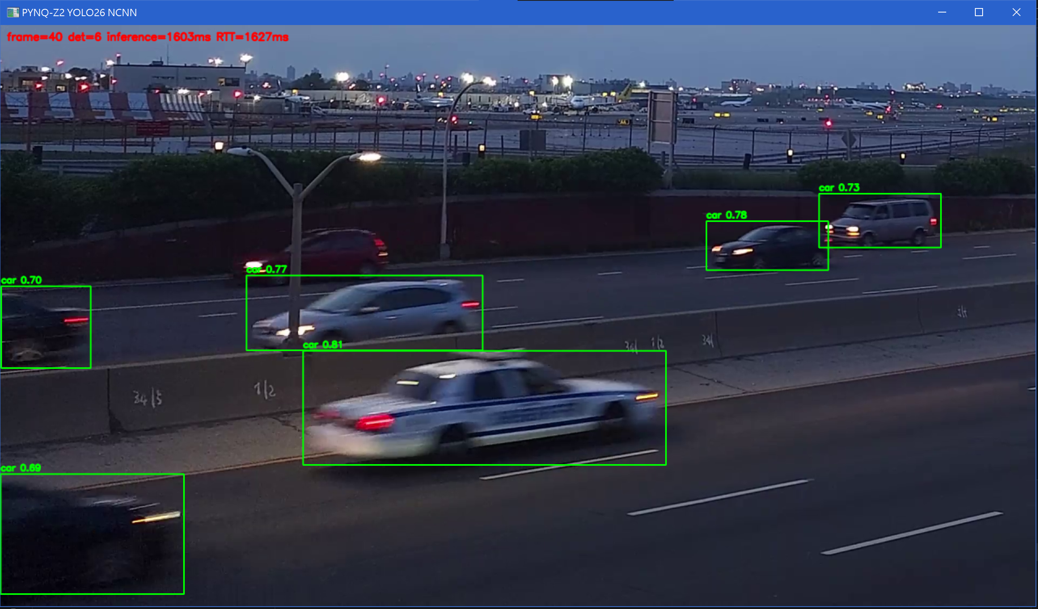
Where det is object counts, interface is ncnn runtime, RTT is round trip time.

